***Module (JQuery Basic, Effects & Advanced) – 5***

1. **What is jQuery?**

jQuery is a fast, small, and feature-rich JavaScript library. It simplifies things like HTML document traversal and manipulation, event handling, and animation. jQuery makes it easier to interact with the Document Object Model (DOM)..

Ex:-

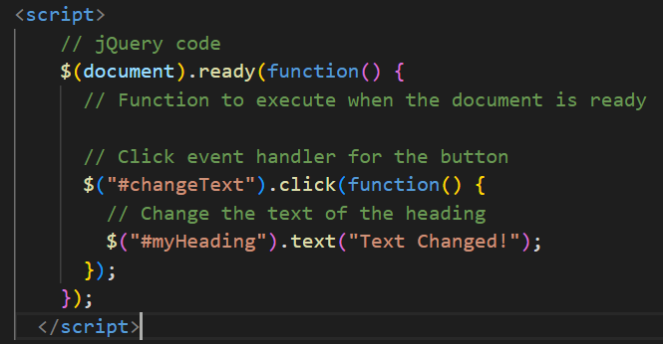

1. **How to Apply CSS Using JQuery, How to Add Class and Remove Class in Jquery , JQuery Animation?**

jQuery makes it easy to manipulate HTML elements and apply CSS styles. Here are examples for applying CSS, adding/removing classes, and using jQuery animations

Applying CSS Using jQuery:

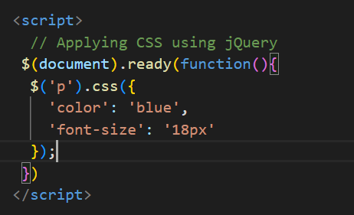

Adding and Removing Classes:

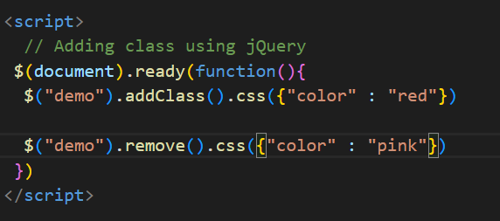

**jQuery Animation:**

1. **How to create slider with animation?**

**You can create a simple image slider with animation using only jQuery. Below is an example of a basic image slider:**

